**Supplemental Table 1.** Descriptive characteristics of unmatched and matched Census Block Groups Between NYCHA and Comparison Groups in New York City

(excluding pre-intervention quarterly incidence rates from matching process)

|  |  |  |  |  |  |  |
| --- | --- | --- | --- | --- | --- | --- |
|  | **All Data (160/5646)** | | | **Matched Data (125/276)** | | |
|  | NYCHA | Comparison Pool | Std. Diff | NYCHA | Matched-Comparison | Std. Diff |
| **Age Group** |  |  |  |  |  |  |
| percent under 5 | 7.23 | 6.24 | 0.21 | 7.25 | 6.83 | 0.09 |
| percent 5 to 11 | 6.71 | 5.47 | 0.31 | 6.78 | 6.40 | 0.09 |
| percent 12 to 17 | 12.23 | 8.40 | 0.71 | 11.97 | 11.86 | 0.01 |
| percent 50 to 64 | 17.44 | 18.54 | -0.19 | 17.46 | 18.01 | -0.09 |
| percent over 65 | 14.45 | 13.61 | 0.08 | 14.20 | 15.32 | -0.11 |
| **Race/Ethnicity** |  |  |  |  |  |  |
| percent African American | 39.47 | 19.89 | 1.06 | 38.92 | 38.25 | 0.03 |
| percent Hispanic | 50.27 | 26.44 | 1.32 | 49.42 | 50.56 | -0.06 |
| **Federal Poverty Level** |  |  |  |  |  |  |
| percent FPL 100 | 44.70 | 17.98 | 2.07 | 43.01 | 41.58 | 0.11 |
| percent FPL 125 | 9.67 | 4.91 | 0.74 | 9.36 | 9.37 | 0.00 |
| **Year Built** |  |  |  |  |  |  |
| percent under 1950 | 33.61 | 55.40 | -1.01 | 36.63 | 36.15 | 0.02 |
| percent over 1950 | 66.39 | 44.60 | 1.01 | 63.37 | 63.85 | -0.02 |
| **Units in Structure** |  |  |  |  |  |  |
| percent under 10 units | 6.65 | 56.66 | -6.25 | 7.3 | 7.47 | -0.02 |
| percent 10-19 units | 7.46 | 5.67 | 0.14 | 7.6 | 8.26 | -0.05 |
| percent 20-49 units | 24.85 | 14.45 | 0.4 | 27.56 | 28.32 | -0.02 |
| percent over 50 units | 60.82 | 23.01 | 1.24 | 57.47 | 55.83 | 0.05 |

Abbreviations: NYC=New York City; NYCHA=New York City Housing Authority, Std Diff=standardized differences; CBG=Census Block Group; FPL=Federal Poverty Level

All characteristics are measured using the American Community Survey Data year 2016 with 5-year estimates. Matched sample incorporates overlap weights. Values are expressed as means

*Standardized differences >0.1

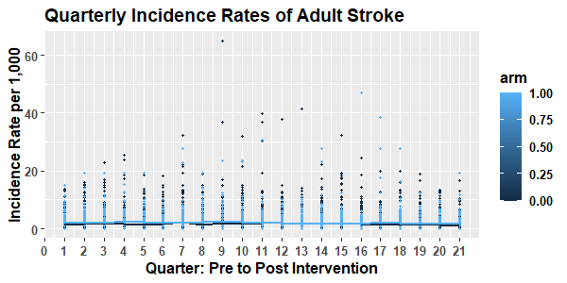**Supplemental Figure 1.** Quarterly Incidence Rates of Adult Myocardial Infarction and Stroke Outcomes, Respectively Between NYCHA population and Comparison Group

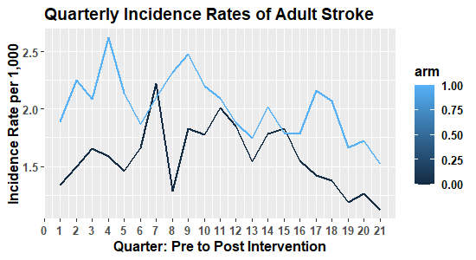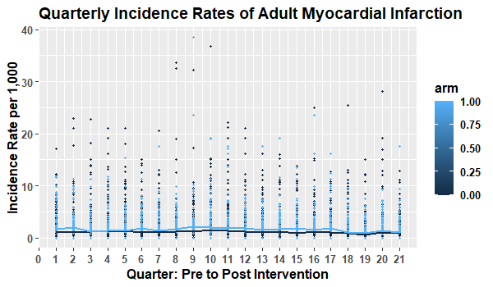

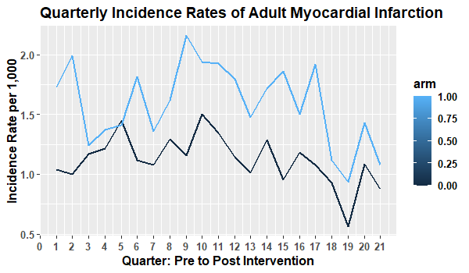

(excluding pre-intervention quarterly incidence rates from matching process)

**Supplemental Table 2.** Difference-in-Differences estimates comparing outcome rate of change between NYCHA population and comparison group, 2015-2020

|  |  |  |  |  |  |  |  |
| --- | --- | --- | --- | --- | --- | --- | --- |
| **Effecte** | **CBG**  **(N obs.)** | **Mean Difference**  **Baseline vs. 24 months Post-Policy**  **MD (95% CI)** | **D-I-D Estimate**  **Baseline to 24 months Post-Policy** | **p-value** | **Mean Difference**  **Baseline vs. 36 months Post-Policy**  **MD (95% CI)** | **D-I-D Estimate**  **Baseline to 36 months Post-Policy** | **p-value** |
| ***Myocardial Infarction*** |  |  |  |  |  |  |  |
| NYCHAa | 125 | -0.31 (-0.57, -0.05) | -0.04 | 0.78 | -0.43 (-0.77, -0.09) | -0.19 | 0.34 |
| Matched Comparisonb | 276 | -0.27 (-0.45, -0.10) | -0.23 (-0.46, -0.004) |
| ***Stroke*** |  |  |  |  |  |  |  |
| NYCHAa | 125 | -0.26 (-0.57, 0.04) | 0.017 | 0.92 | -0.56 (-0.96, -0.15) | -0.08 | 0.72 |
| Matched Comparisonb | 276 | -0.28 (-0.48, -0.07) | -0.47 (-0.75, -0.20) |

SPARCS Dataset 2015-2020. Abbreviations: D-I-D=Difference-In-Differences; CBG=Census Block Group; MI=myocardial infarction

a100% NYCHA Census Block Groups (n=125)

bPropensity score matched Census Block Groups (n=276) matched on age, race/ethnicity, poverty status, built environment

eD-I-D Estimates and p-values correspond to coefficient associated with treatment time interaction in Mixed Linear regression model between baseline and 36 months’ post-policy. Models including matching weights and control for age category, race/ethnicity, federal poverty level, and built environment

(excluding pre-intervention quarterly incidence rates from matching process)

**Supplemental Table 3.** Difference-in-Differences estimates comparing outcome rate of change between NYCHA population and comparison group, 2015-2020

|  |  |  |  |  |  |
| --- | --- | --- | --- | --- | --- |
| **Effecte** | **CBG**  **(N obs.)** | **Mean Difference**  **Baseline vs. 24 months Post-Policy**  **MD (95% CI)** | **D-I-D Estimate**  ***(p-value)*** | **Mean Difference**  **Baseline vs. 36 months Post-Policy**  **MD (95% CI)** | **D-I-D Estimate**  ***(p-value)*** |
| ***Myocardial Infarction*** |  |  |  |  |  |
| NYCHAa | 118 | -0.21 (-0.41, -0.02) | 0.20  *(p=0.12)* | -0.17 (-0.42, 0.06) | 0.18  *(p=0.31)* |
| Matched Comparisonb | 256 | -0.41 (-0.58, -0.25) | -0.36 (-0.61, -0.11) |
| ***Stroke*** |  |  |  |  |  |
| NYCHAc | 113 | -0.19 (-0.39, 0.008) | 0.007 | -0.38 (-0.60, -0.15) | -0.02  *(p=0.88)* |
| Matched Comparisond | 254 | -0.20 (-0.35, -0.04) | *(p=96)* | -0.36 (-0.53, -0.18) |

SPARCS Dataset 2015-2020. Abbreviations: D-I-D=Difference-In-Differences; CBG=Census Block Group; MI=myocardial infarction

a100% NYCHA Census Block Groups (n=118)

bPropensity score matched Census Block Groups (n=256) matched on age, race/ethnicity, poverty status, built environment, and pre-intervention adult MI quarterly rates

c100% NYCHA Census Block Groups (n=113)

dPropensity score matched Census Block Groups (n=254) matched on age, race/ethnicity, poverty status, built environment, and pre-intervention adult stroke quarterly rates

eD-I-D Estimates and p-values correspond to coefficient associated with treatment time interaction in Poisson regression model between baseline and 36 months’ post-policy. Models including matching weights and control for age category, race/ethnicity, federal poverty level, and built environment

**Supplemental Figure 2.** Linearity Diagnostic Testing to Assess Normality of Residuals and Homoscedasticity

1. b)

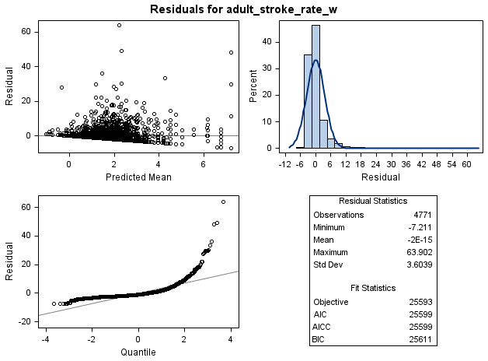

**Residuals for Quarterly Incident Rate of Adult Stroke**

**Residuals for Quarterly Incident Rate of Adult MI**

